How to clear browser cache:
Keyboard Shortcut: Ctrl+Shift+Delete on a PC or Cmd+Shift+Delete on a Mac.
In Google Chrome:
- On your computer, open Chrome.
- At the top right, click More .
- Click More tools Clear browsing data.
- At the top, choose a time range. To delete everything, select All time.
- Next to "Cookies and other site data" and "Cached images and files," check the boxes.
- Click Clear data.
In Microsoft Edge:
- Click the Menu icon at the top-right corner of the screen, then click Settings.
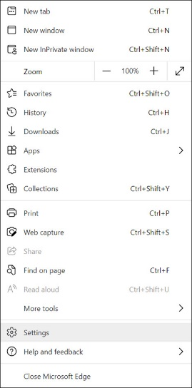
- Click on Privacy, search, and services from the list of options on the left-hand side under Settings.
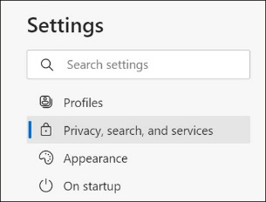
- Scroll down to Clear browsing data and click Choose what to clear.
- Change the Time range at the top to All Time and check the boxes next to Cookies and other site data and Cached images and files. Then, click Clear now.

